- Verify the Concern
  - Start machine. Full engine speed. Turn AC on full cold. Blower on high. Close cab door and windows. Operate AC for 5 minutes.
  - Measure duct temperature
    - Proper functioning AC louver temperature is between 45-53 DegF. (Not uncommon to get below 40degF.)
- Inspect the Machine
  - Coolers/condenser restricted or extremely dirty?
  - Compressor clutch engaging?
  - Engine accessory belt(s) in good condition? If not, compressor rotates?
  - Fresh air and recirculating filters restricted?
  - Debris behind operator seat plugging recirculating filter?
  - Blower noisy or weak?
- List Possible Causes and
- Determine Root Cause
Bypass the first failure and make the rest of the system functions before quoting the customer.
  - Air flow
Low air volume from the ducts or restricted air flow through the evaporator and condenser will cause warm air from the ducts.
    - Cab filters
    - Restrictions in condenser and evaporator
    - Blower function or speed
    - HVAC box drains / evaporator freezing
  - Electrical
Key on, engine off test: Turn AC on. After a 6 second MCC delay, clutch should engage. R-Series cycles the clutch for a soft start.
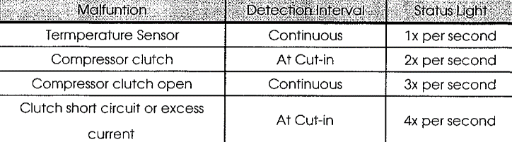
    - Check the MCC flash codes.
    - AC switch corrosion - Voltage drop or bypass test is important here. A dim light in the switch can indicate corrosion in the switch.
    - Compressor clutch – bypass with a high current test light in its place to verify the rest of the system.
    - Pressure switch – Bypass switch and install gauge set to check charge
  - Refrigerant charge
Low refrigerant pressure will prevent the compressor from engaging. Charge an empty system with a pound– Look and listen.
    - R-Series: Pressure switch can be bypassed without raising the cab.
    - Hose and/or fitting leaking – look for oil residue
    - Compressor leaking – Soapy water
  - Heater control valve.
Hot coolant can bypass the heater valve and heat the heater core.
    - Clamp the heater hose to block any possible coolant flow
    - Key on/Engine off. Change temperature control setting and monitor heater coolant valve rotation.
  - Compressor
Visually inspect the compressor. If the belt is damaged or off, engage the compressor clutch and rotate the compressor by hand. Using an infrared temperature gun, measure the compressor housing temp while the system is operating. Compressor should be near engine temperature. Too little oil quantity will cause compressor to overheat.
    - Seized
    - Mounting incorrect
    - Belt
    - Oil quantity
- Repair the machine according to the latest service information.
  - Use MyMachine to check for service letters or Knowledge Articles.
  - Replace the Dryer if system has been opened
  - Use the proper amount of oil
- Verify the Repair
  - Start machine. Full engine speed. Turn AC on full cold. Blower on high. Close cab door and windows. Operate AC for 5 minutes.
  - Measure duct temperature
    - Proper functioning AC louver temperature is between 45-53 DegF.
- Write the Service Report
  - Concern, Cause, and Correction
  - Include results of verifying the concern and verifying the repair
  - Include only the diagnostic steps that lead to the successful repair

